2020 Maryland Counseling Association Virtual Conference Program
Program Editor: Stacey Morgan

Sponsored by

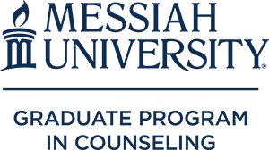

Soon offering the new ACPE Spiritually Integrated Psychotherapist (SIP) credential!

Day 1 Live Conference October 9, 2020

All times are Eastern Daylight Saving Time (EDT)
9:00 – 9:15 AM | Welcome and Opening of Conference –  Dr. Carol ZA McGinnis 2020-2021 MCA President  Dr. Sarah Pula 2020-2021 MCA President Elect  Melissa Wesner – Conference Co-chair  Donnette Deigh – Conference Co-chair
9:15 – 10:15 AM | Session #1:  How to Market and Grow a Faith-based Practice  Whitney Owens LPC (GA), MA
10:15 – 10:30 AM | Session #1 Q&A w/Whitney Owens  OR  Break  OR  Brief Self-care Activity
10:30 – 11:30 AM | Session #2:  Using Creative Techniques in Counseling Supervision to Enhance Counselor Development and Identity  Donnette Deigh MA, LGPC, NCC
11:30 – 11:45 AM | Session #2 Q&A w/Donnette Deigh  OR  Break  OR  Brief Self-care Activity:
11:45 – 12:45 PM | KEYNOTE SPEAKER  "If You Don’t Mind, Can I Be...What Are the Ingredients to Help Me to Grow?"  ##cultivating growth  Dr. Deborah G. Haskins, LCPC, ACS, MAC, ICGC-II, BACC, CCGSO
12:45 – 1:00 PM | Q&A with Dr. Deborah G. Haskins  OR  Break  OR  Brief Self-care Activity
1:00 – 2:00 PM | Session #3:  When's the last time you've breathed?: All it takes is 10 Mindful Minutes  Dr. Lenese N. Stephens LCPC, LPC, ACS, BC-TMH
2:00 – 2:15 PM | Session #3 Q&A w/ Dr. Lenese N. Stephens  OR  Break  OR  Brief Self-care Activity
2:15 – 3:15 PM | Session #4:  Cultivating Growth through Brainspotting  Melissa Wesner LCPC (MD), LCMHC (NH), Certified Brainspotter
3:15 – 3:30 PM | Session #4 Q&A w/ Melissa Wesner  OR  Break  OR  Brief Self-care Activity:
Simultaneous 30 Minute Exhibitor, Self-care, Networking, and Other Sessions
3:30 PM – 5:00 PM
3:30 PM – 4:00 PM | Exhibitor Spotlight #1:  Guided Meditation/Breathing/Mindfulness Exercise  with Arti Kumar-Jain, NCC, M.Ed., CHC, CPC, CYPFC  https://loveandlight4kidzllc.com/  Exhibitor Spotlight #2:  Mindfulness and Nature Based Therapeutic Techniques for Children  with Cheryl Fischer  https://www.cfisherandassociates.com/  Exhibitor Spotlight #3:  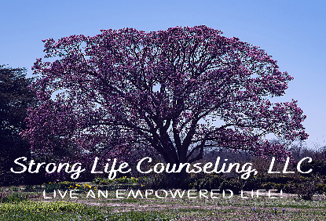  Strong Life Counseling, LLC  with Kerri Legette McCullough  www.stronglifecounseling.com
4:00 PM – 4:30 PM | Exhibitor Spotlight #4:  with Janet Glover – Kerkvliet  www.bjhsg.org  Exhibitor Spotlight #5:  with Dr. Lenese N. Stephens  www.hopefulcounseling.org  Exhibitor Spotlight #6:  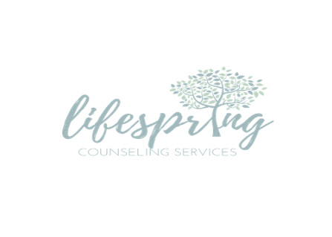  with Melissa Wesner  lifespringcounseling.net  Division Spotlight:  MASERVIC Social and Book Raffle with Dr. Maya Georgieva
4:30 PM – 5 PM | Exhibitor Spotlight #7:  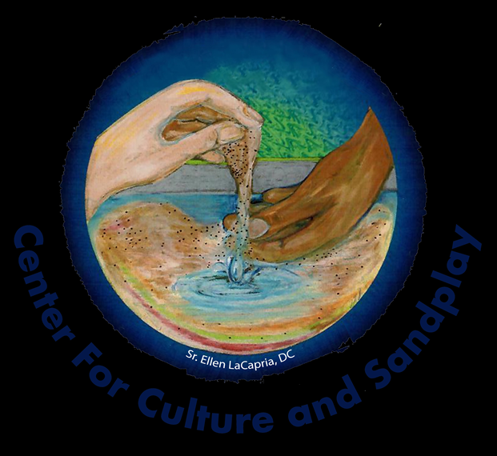  with Dee Preston-Dillon  sandtherapytraining.com  Exhibitor Spotlight #8:  with Lisa Oliver, CAP, OM, MCT  here2helpva.com  Exhibitor Spotlight #9:  with Melissa Wesner  protectingyourpractice.com
5 – 6 PM  OR  5 – 6 PM | Surprise CE Session!  Cultivating Growth in Counselor Trainees Through the Integration of Trauma-Informed & Trauma-Responsive Practices  Diane Marie Reese, Ph. D  Social Time: Bring a drink and share some collegial time with your friends who may share experience or a desire to hear your thoughts in the field on topics such as (no time requirement is expected – come and go as you please):  - EMDR, Trauma, or Abuse  - Working with the Elderly and Second Career  - Counselors who work with families and children  - Substance abuse, MI, or other “difficult” populations
Hope you had an informative and fun day! “See” you tomorrow!

2020 Maryland Counseling Association Virtual Conference Program

Sponsored by

Soon offering the new ACPE Spiritually Integrated Psychotherapist (SIP) credential!

Day 2 Live Conference October 10, 2020

All times are Eastern Daylight Saving Time (EDT)

9:00 – 9:15 AM | Welcome and Opening of Day #2 –  Dr. Carol ZA McGinnis 2020-2021 MCA President  Dr. Sarah Pula 2020-2021 MCA President Elect  Melissa Wesner – Conference Co-chair  Donnette Deigh – Conference Co-chair
9:15 – 10:15 AM | Session #1:  Narrative Therapy: The Power of the Best Friend Method  Janai Manning MA
10:15 – 10:30 AM | Session #1 Q&A w/Janai Manning  OR  Break  OR  Brief Self-care Activity
10:30 – 11:30 AM | Session #2:  Use Counseling Skills to Cultivate Advocacy Efforts  Janelle Cox Ed.D, LCPC, NCC, ACS
11:30 – 11:45 AM | Session #2 Q&A w/Janelle Cox  OR  Break  OR  Brief Self-care Activity:
KEYNOTE SPEAKER
11:45 – 12:45 PM | "The Importance of Counselor Self-Care in the era of Covid-19 and Anti-racism"  Richard Yep, CAE, FASAE
12:45 – 1 PM | Q&A with Richard Yep  OR  Break  OR  Brief Self-care Activity
1 – 2 PM | Session #3:  Deepening Counselor Insight and Creativity with Symbols in Sand  Dr. Dee Preston- Dillon MA, PhD
2:15 – 2:30 PM | Session #3 Q&A w/ Dee Preston-Dillon  OR  Break  OR  Brief Self-care Activity
2:30 – 3:30 PM | Session #4:  Growth During Uncertainty: Organizational and Clinical Implications  Amy Greensfelder
3:30 – 3:45 PM | Session #4 Q&A w/ Amy Greensfelder  OR  Break  OR  Brief Self-care Activity:
Simultaneous Exhibitor, Self-care, Networking, and Other Sessions 3:45 PM – 4:15 PM

3:45 – 4 PM | Break!
4 – 5 PM | Awards Ceremony!  This Photo by Unknown Author is licensed under CC BY-NC
5 – 6 PM | Social Time: Bring a drink and share some collegial time with your friends who may share experience or a desire to hear your thoughts in the field on topics that may include the following (no time requirement is expected – come and go as you please):  - People who work with EMDR, Trauma, or Abuse  - Working with the Elderly and Second Career  - Counselors who work with families and children  - Substance abuse, MI, or other “difficult” populations
Hope you had an informative and fun time at this virtual conference!

Alphabetical Presenter Listing of Recorded Webinars

Available October 9, 2020 until January 15, 2021
Augustine | “Cultivating Success and Acceptance: Mentoring Minoritized Counseling Trainees”  This educational session will explore the use of critical race theory (CRT) as a framework for culturally sensitive and affirming mentorship. The history and aims of CRT, strategies for incorporating CRT into mentorship, and the potential benefits for mentees, the mentorship relationship, and the working environment will be discussed.
Chamberlin | “Addressing Multicultural Competencies and Multicultural Orientation in Study Abroad Experiences”  As study abroad and cultural immersion experiences continue to grow in popularity, counselor education programs should consider not only the benefits of these experiences for student development, retention, and overall satisfaction, but also for students to learn and cultivate multicultural competency (MCC) development and multicultural orientation (MCO) understanding. This presentation will address the importance of utilizing study abroad programs as platforms for learning both MCCs and MCOs.
Davis | “Environmental and Treatment Considerations for Intimate Partner Violence Following the Impact of Covid 19”  This presentation discusses the implications for working with domestic violence victims and survivors prior to and during the COVID-19 pandemic. It explores the challenges of the changing framework for counseling from traditional to telehealth services. Evidence-based treatments, interventions, and resources will be shared with participants.
Davis | “Intersection of Post-Traumatic Growth and Forgiveness: A Catalyst for Healing”  This presentation will connect the experience of post-traumatic growth with the empirical support of forgiveness as an intervention with survivors of trauma. Research specific to the link between Post-Traumatic Growth and Forgiveness will be examined with the formulation of a tool-kit appropriate to this therapy.
Farmanara | “Duty to Warn: A Guide for Counselors”  The duty to warn in the counseling profession has been more recognizable since the Tarasoff decision of the Supreme Court of California in 1976. While it is known that counselors, as well as others in the helping profession fields, have a duty to warn upon a client posing an imminent threat to themselves or others, there have been continuous disputes regarding what constitutes a credible threat. Join us for a look at what constitutes a credible threat, grey areas, and different scenarios to work through.
Fisher | “Eco-Anxiety and the Role of Eco-Spirituality in Treatment”  Eco-anxiety refers to the fear or anxiety to threats from the environment. Natural disasters, environmental diseases (pre-COVID19) and resulting loss of home, family and livelihood has resulted in more than 70% of the world experiencing depression and anxiety. While not an official DSM-5 diagnosis, mental health professionals are observing an increase in presenting concerns in their practices. Symptoms include trauma response, generalized anxiety, post-traumatic stress disorder, feelings of helplessness, depression, substance abuse, and aggression.  Eco-Spirituality refers to the worldview that all creatures are inter and intra connected. Humans and other-than human beings have a reciprocal relationship. Researcher, Valerie Lincoln (2000) identified five tenets of eco-spiritual consciousness. These include tending, dwelling, reverence, connecting, and sentience. These experiences guide processes toward rediscovering eco-agency, validation of mutuality and reciprocity of experiences of suffering, healing and growth, and an understanding of mystery and the Sacred. Ultimately, an Eco-Spiritual consciousness (informed by Eco Feminism and Eco-Womanism) invites inclusivity and advocacy for self, the Earth, and all of creation.  Join Dr. Cheryl Fisher, PhD, NCC, LCPC as she discusses how tapping into eco-spiritual consciousness aids in the treatment of eco-anxiety.
Gardner | “LGBTQ Aging Considerations”  This presentation provides an overview of the various definitions of aging. It then segues into ethical standards related to aging, LGB, and TNC populations. Clinicians and provided with special considerations when working therapeutically with aging LGB and TNC patients. Theories of LGBT development are also discussed.
Gasser | “Building Career Adaptability with Culturally Diverse Clients Promoting Career Development through Theory, Research, and Practice”  Clients need to flex and grow more than ever as they seek to adapt to and cope with the uncertainties and changes faced in the current world of work. The disparities in employment faced by marginalized and oppressed groups has been heightened as a result of the pandemic, and counselors need to be prepared to help clients enhance their career adaptability (career-related coping) in order to navigate issues such as joblessness, career transitions, and job uncertainty. Our presentation seeks to help counselors cultivate their own growth as well as that of their career clients.
Georgieva | “Sandtray Therapy & Polyvagal Theory: Practical Implications for Trauma Treatment”  Conceptualizing effective trauma treatment through the lens of polyvagal theory requires counselor and client to engage in a process of co-regulation. Utilizing creative approaches which activate the right-brain processing mode, such as sandtray therapy, promote client’s successful transition from a place of high alert or immobilization to a sense of safety and healing. This session explains a step-by-step integrative approach through the use of case studies and empirical evidence.
Glover-Kerkvliet | “Workplace Bullying: A Guide for Clinicians”  Sixty million Americans have experienced or observed repeated, health-harming, mistreatment of one or more persons by one or more perpetrators on the job. Workplace bullying is abusive conduct that is threatening, humiliating, and/or intimidating. Most workplace bullying is not illegal or prosecutable. Participants will explore what they can do for clients, examine case studies, and learn about the Maryland Freedom from Bullying Task Force, which will promote the professional development of mental health and career counselors in expanding their ability to assist people experiencing abuse at work and uphold the honor and respect for human dignity that all workers deserve.
Glover-Kerkvliet | “#MyPandemicJobSearchPlan: A Community-Based Intensive Incubator for Older Workers Unemployed due to the COVID-19 Crisis”  Re-employment after layoff is often fraught with failure, particularly for the long term unemployed (defined as unemployed for 6+ months). The recent pandemic caused 30 million layoffs and high unemployment rates. Workers who are not re-employed after 6 months are increasingly less likely to find jobs. Research demonstrates that job club participation increases the odds of obtaining gainful work. A local job club assisted unemployed workers via TEAMWORKS, an intensive incubator program. The TEAMWORKS curriculum teaches participants to Re-Charge, Re-Design, and Re-Build their life/career paths. The presenter will discuss learnings from the first cohort and implications for workforce development programs.
Hall | “Trauma-Informed Supervision for Clinicians”  This presentation will identify ways trauma informed supervision can benefit the clinician and the clients served. Additionally, this session will focus on the impact of trauma work on the clinician and ways to integrate trauma informed strategies into the clinical supervision setting.
Hinds | “Responding to Cultural Differences and Racism in Play Therapy w/Emphasis on African American Children and Families”  Red, yellow, Black, Brown and White skin colors comprise the human race. Regardless of skin color and life circumstances, all clients are to be treated with respect and dignity for who they are. When working with children, the conversation of ethnicity and racial differences does take some thought as it often surfaces in subtle ways. Using discussion and case scenarios this presentation will provide strategies to initiate conversation as well as respond therapeutically to children's curiosity about ethnicity and culture. Resources for clinicians and parents to continue conversations will be provided.
Matowe | “The Prevalence of Racial and Ethnic Health Disparities: What Do They Have To Do with This Year's Racial Protest and How Do We Move Forward?”  Health disparities among racial and ethnic minorities in the United States have been well- established and have remained relatively unchanged in over 30 years: minorities have less access to and are less likely to receive the necessary treatment for physical and mental health concerns. Disparities in the treatment of chronic diseases such as cancer, HIV/AIDS, diabetes, heart disease, and mental illness affecting minority populations have also been widely reported. Contributing factors include, but are not limited to race, ethnicity, lack of insurance, socioeconomic status (SES), access, provider mistrust, racism, and discrimination. This presentation will review the prevalence of racial and ethnic health disparities, explain how these disparities are connected to the current racial protests and police violence, and discuss the role of providers in addressing this issue.
McGinnis | “Counseling Xbox "First Person Shooter" Videogamers: Virtual World Interventions”  Counselors often struggle with understanding and using the online videogaming environment as a way to assist clients toward short-term and long-term goals. Content specific to Xbox “first person shooter” games is presented within a clinical view in this presentation with consideration of common issues and diagnoses. Realistic examples follow a rudimentary walk-through of what these environments may represent for counselors who would like to invite more game-related discussion in session and collaborative goal-setting that will use that environment to transition new skills offline.
Morgan | “Introduction to EFT: The Benefits and Science Behind Emotional Freedom Technique”  This is an introduction to the mechanism of action and use of Emotional Freedom Technique to manage psychological and physiological distress associated with anxiety, stressful or traumatic life experiences.
Nyang | “How to Integrate Tai Chi into Your Mental Health Practice”  Are you looking for something to bring relaxation and energy to your clients? Want to use a technique that is more than the usual "therapy" process? Tai Chi does this and much more. A growing body of research supports that it is a combination of gentle exercise, breath work, and focus offers a host of benefits for improved mental and physical health. Tai Chi can help reduce stress, depression. You will learn the basic skills of Tai Chi and discover how to incorporate it into your treatment plans.
Pula | "Suicide Risk Assessment during a Pandemic"  In this webinar, Dr. Sara Pula, presents information on the complications of conducting a suicide risk assessment during a pandemic. Such information includes challenges around isolation, increased anxiety and uncertainty, and treatment through telehealth. This presentation includes a protocol on conducting a virtual assessment.
Sorrell | “Resiliency and Layers in the Storm: How African Americans Cope with the COVID-19 Pandemic among Layers of Grief, Racism and Distrust”  The COVID-19 pandemic of 2020 has been described as one of the worst global disasters in many individual’s lives. This workshop will address how the COVID-19 pandemic specifically affected the mental health of African Americans with the underpinnings of racism and healthcare disparities in the background. This presentation will also discuss how African Americans coped and found resiliency through this pandemic.
White | “Bracketing, Broaching, Boundary-ing, and Breathing: How Counselors of Color Can Stay in the Room and At the Table”  Counselors of Color (COC) are a growing population in the predominantly White profession of counseling. COCs endure other challenges in the therapy room that often are not addressed in research and training. It is necessary to build space for decolonizing minds to address the historical legacy of Euro-centric ideologies and perpetual social injustices to provide culturally relevant services. This presentation will highlight issues that Counselors of Color experience with bracketing, broaching, setting boundaries with colleagues, and overwhelm. Counselors will be offered strategies to promote wellness and maintain efficacy.

Live Presenter Information

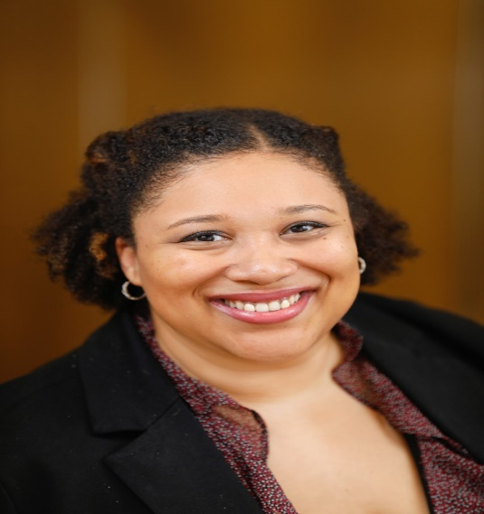

Dr. Janelle Cox
Dr. Janelle Cox is an Assistant Professor and Program Coordinator in the Mental Health Counseling Program at Bowie State University. She is also a Nationally Certified Counselor (NCC), Approved Clinical Supervisor (ACS), Licensed Clinical Professional Counselor (LCPC), and Board Approved Clinical Supervisor in the State of Maryland. Dr. Cox has her Master of Arts in Community Counseling and Doctor of Education in Counselor Education and Supervision. Dr. Cox has experience working with children, adolescents, and adults with a myriad of diagnoses such as bipolar, depression, anxiety, ODD, ADHD.

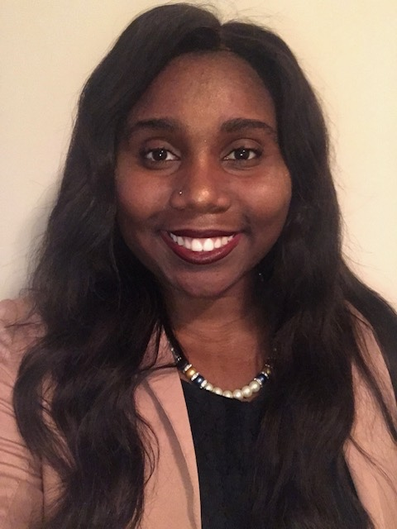

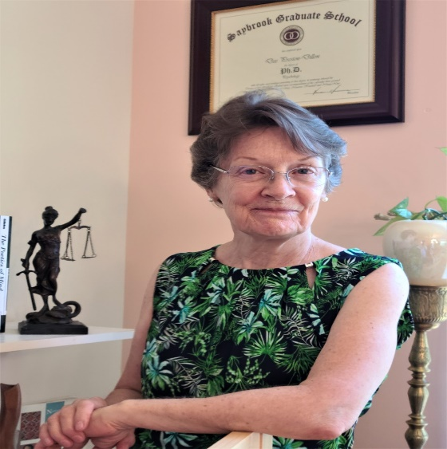

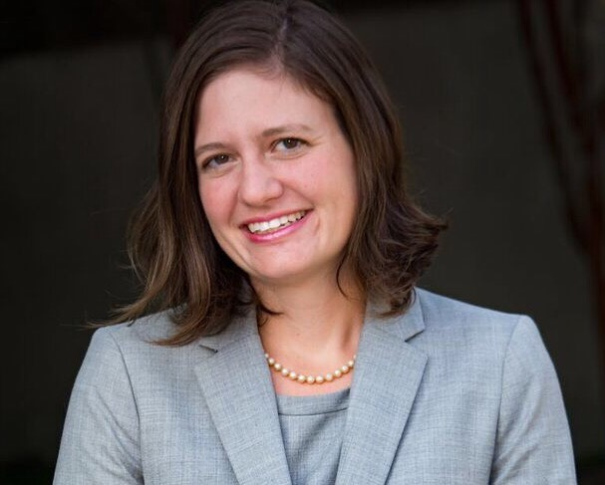

Donnette Deigh, PhD
Donnette Deigh is a PhD student in Liberty University’s Counselor Education and Supervision program. Donnette is currently an Education Services Specialist, National Certified Counselor and a provisional therapist working on her independent license in the state of Maryland. Donnette has been dedicated in helping underserved populations increase their quality of life. Her areas of specialization include anxiety, adjustment difficulties/ life transitions, job dissatisfaction/career counseling, and depression.

Dee Prestion-Dillon, M.A., Ph.D
Dee Preston-Dillon, M.A., Ph. D, founder, the Center for Culture and Sandplay, clinician educator, a professor of psychology, she completed her process in Sandplay in the early 1980s. For 45 years Dee infused creativity into her graduate counseling and clinical psychology courses. Her cross-cultural research compared Jungian conceptualization of sand scenes with three indigenous perspectives.

Amy R. Greensfelder, LMSW
Amy Greensfelder (she/her) is the Executive Director at the Pro Bono Counseling Project. She joined PBCP in September 2017. Ms. Greensfelder is a Licensed Masters Social Worker (LMSW) and a graduate of the University of Maryland Baltimore School of Social Work. Previously, Ms. Greensfelder served at the Maryland Department of Health’s Refugee Mental Health Program Coordinator. In that role she developed the state of Maryland’s refugee mental health program which includes screening of newly arrived refugees for mental health concerns, support groups, training of mental health providers.
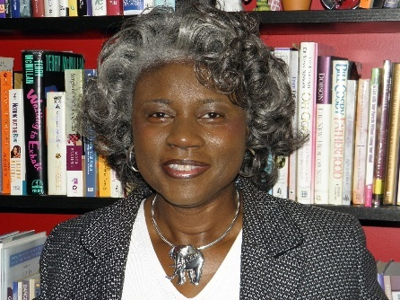

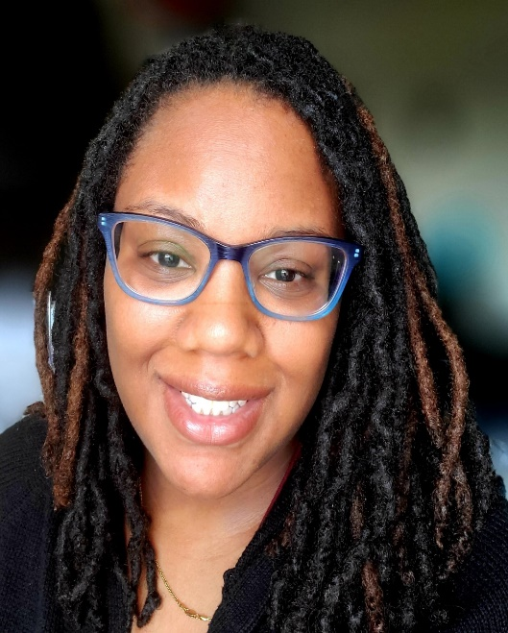
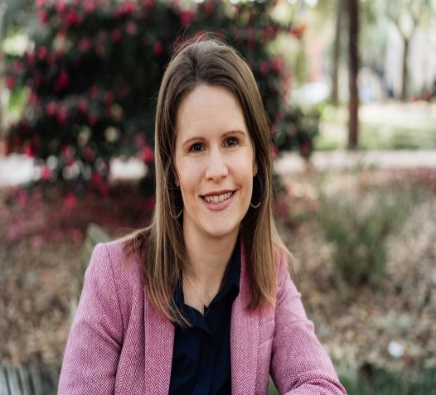

Dr. Diane Reese
Dr. Diane Reese is an Assistant Professor of Counseling at Trinity Washington University in Washington, DC. She is lead faculty of the School Counseling Program and teaches additional foundational counseling courses in the Counseling Department. Dr. Reese is a member of the Initiative on Adverse Childhood Experiences (ACEs) and Trauma Research Team.
Dr. Reese has worked in three Virginia school districts as a professional school counselor, High School Director of School Counseling, District Director of School Counseling and District Coordinator of School Counseling. She has held leadership positions with the Virginia School Counselor Association (VSCA) and is currently serving her last year of a three-year term on the American School Counselor Association’s (ASCA) Board of Directors. She is also a member of the American Counseling Association and the Virginia School Counselor Association.

Janai Manning
Janai Manning is a School-Based Therapist at Johns Hopkins. She is also a Licensed Graduate Professional Counselor (LGPC) and a Nationally Certified Counselor (NCC) in the state of Maryland. Janai has her Masters of Arts in Clinical Mental Health Counseling and is currently getting her Ph.D. International Psychology with a trauma focus. Janai has experience in working with children, adolescents, and adults with a myriad of diagnoses such as schizophrenia, borderline personality disorder, bipolar disorder, anxiety, depression, adjustment disorder, and ADHD. Janai has experience working in a variety of settings such, crisis homes, clinics, within the legal system, and telehealth. Research interests include social justice/advocacy, community violence, music therapy, race-based trauma, and generational trauma.

Whitney Owens
Whitney is originally from Valdosta, Georgia and has a master’s degree in Professional Counseling from Richmont Graduate University in Atlanta. GA. Following graduate school, Whitney and her husband immediately moved to Denver, CO where she built a private practice while also doing inpatient work at a local hospital. In 2014 they moved to Savannah, Georgia and Whitney started Water’s Edge Counseling. Whitney is married with two beautiful girls ages five and one.

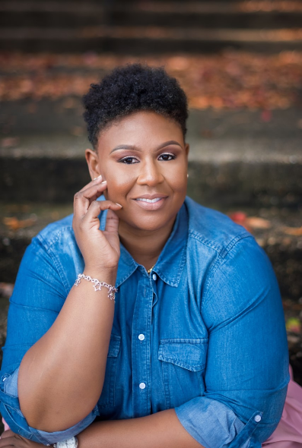

Melissa Wesner
Melissa Wesner is a Licensed Clinical Professional Counselor who strives to provide adults with hope, healing, and empowerment through the collaborative process of counseling. Melissa is the owner of Lifespring Counseling Services, a group practice in Towson, MD. She is a sex therapist and Certified Brainspotter who helps people work through depression, anxiety, trauma, and substance use. Melissa holds a Master’s Degree in Clinical Community Counseling and a Post-Master’s Certificate in Spiritual and Existential Approaches to Counseling from Johns Hopkins University.

Dr. Lenese Stephens
Dr. Lenese N. Stephens, is a mental health group private practice owner, Hopeful Counseling, is a licensed professional counselor and has research interests in mindfulness practices to enhance emotional development, social cultural factors related to body-image and positivity and counselor education and supervision.

Recorded Webinar Presenters

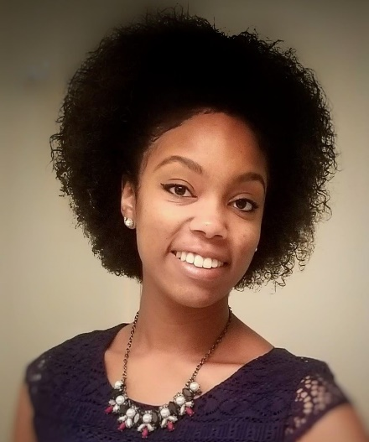
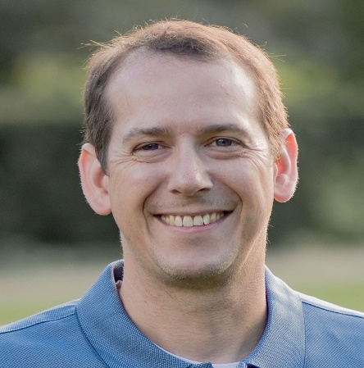
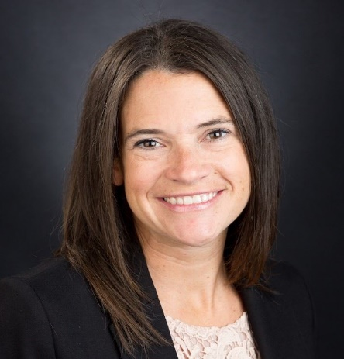

Bianca R. Augustine CCTP
Bianca R. Augustine CCTP is a doctoral student in counselor education and supervision at Old Dominion University in Norfolk, Virginia. She obtained her bachelor’s degree in psychology and Master of Arts in psychology with a concentration in counseling at McNeese State University in Lake Charles, Louisiana. Her clinical interests include mental health counseling with minoritized ethnic groups and those with affectional and gender expansive identities, as well as counseling concerns related to sexuality, trauma, and grief.
Dr. David R Brown

Dr. David R. Brown has worked in counselor education since 2008 and has been licensed as a professional counselor since 2005 and as a chemical dependency counselor since 2013. Dr. Brown regularly presents at state, regional, and national conferences and serves on the Board of Directors for the Greater Cincinnati Counseling Association.

Brandi Chamberlin

Brandi Chamberlin has worked in many clinical settings including intensive in-home therapy, drug and alcohol rehabilitation, the geriatric psychiatric unit, the adult psychiatric unit as well as group and family work with individuals and families dealing with substance abuse issues.

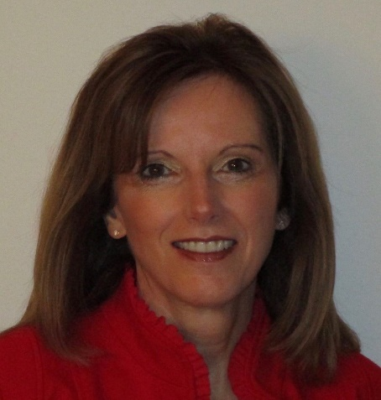

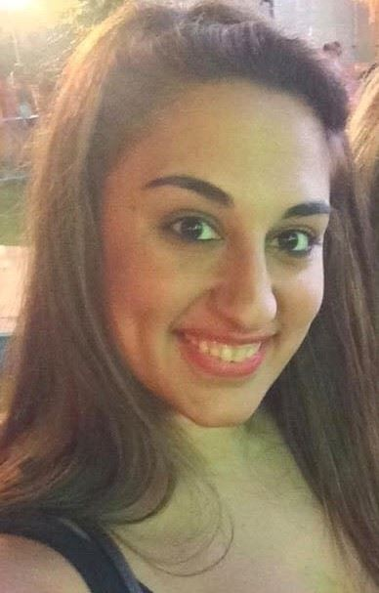

Jama Davis, PhD, LMHC (IN), LPC (NC), NCC
Jama Davis is an Associate Professor and Core Faculty member in the CACREP accredited Clinical Mental Health Counseling program at Liberty University.
Her work in the counseling profession as a counselor, supervisor and professor spans over 30 years, leading her to counsel and teach internationally. She regularly presents at peer-reviewed conferences and has published in textbooks and for professional associations.
Lilia Farmanara, M. Ed., NCC, NCSC
Lilia Farmanara, M. Ed., NCC, NCSC is a Professional School Counselor in St. Lucie County, Florida. She grew up in Anne Arundel County, Maryland.
She is currently a School Counselor at two alternative education sites working with both incarcerated youth and youth in a substance abuse treatment program. She is in the second year of her doctorate at Florida Atlantic University studying Counseling Education and Supervision with hopes of becoming a Professor at the University level to help counselors in training excel to the best of their ability.

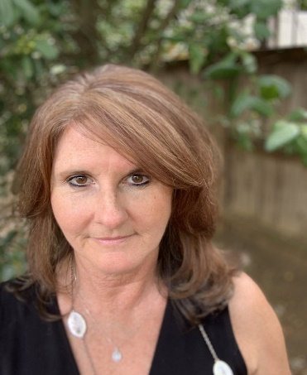

Dr. Cheryl Fisher
Dr. Cheryl Fisher is a certified trauma specialist with over 20 years of clinical experience and has deployed locally and nationally with the American Red Cross Disaster Mental Health Team and Maryland Responds Medical Corp. Her research interests include the role of spirituality in overall well-being, and the therapeutic benefits of engaging in nature.

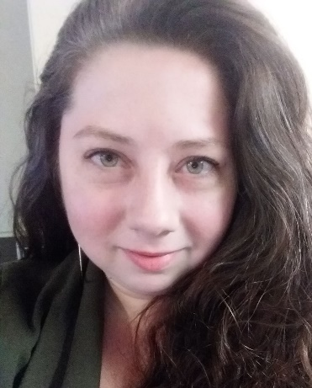

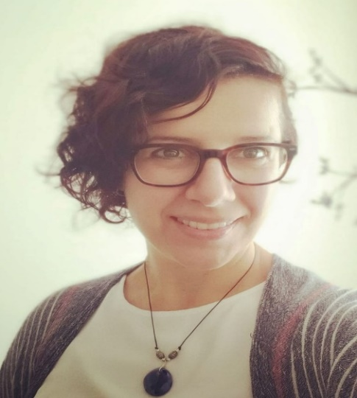

.
Sarah K. Gardner
Sarah K. Gardner, Psy.D., NCC, LCPC is a neuropsychology post-doctoral fellow at the Moore Counseling Center in Moore, Oklahoma. Dr. Gardner received her Psy.D. in clinical psychology at The Chicago School of Professional Psychology, Washington, D.C. and earned her M.A. in clinical psychology en route at the American School of Professional Psychology, Washington, D.C, at Argosy University.

Courtney E. Gasser, Ph. D

Courtney E. Gasser, Ph.D. is a counseling psychologist licensed in the state of Maryland, a nationally certified counselor, and a Maryland Board of Professional Counselors and Therapists approved supervisor. Dr. Gasser is an Associate Professor of Applied Behavioral Sciences and Director of the M.S. in Applied Psychology-Counseling Psychology program at the University of Baltimore. She received her doctoral degree from Iowa State University, where she trained as a counselor, researcher, and instructor, and developed specialties in vocational psychology and counseling supervision.

Dr Maya Georgieva
Dr. Maya Georgieva is a licensed professional counselor in both Virginia and Maryland. She is also a full-time college professor at the graduate counseling program at Messiah University in Pennsylvania. She has presented on the topics of counseling, mental health, and wellness at local, national, and international conferences.

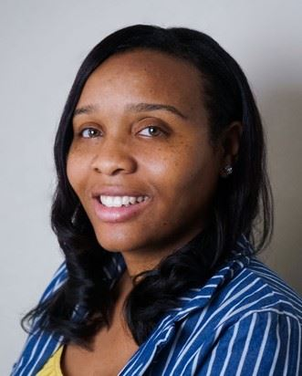

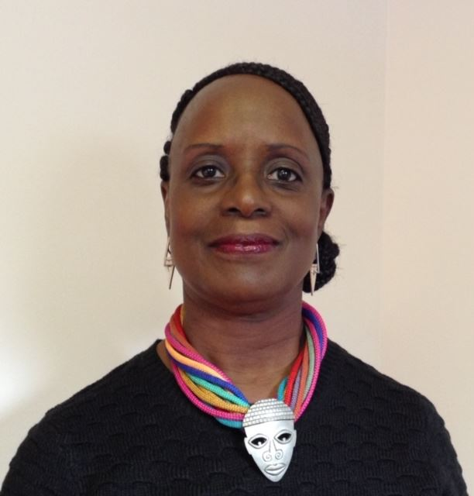

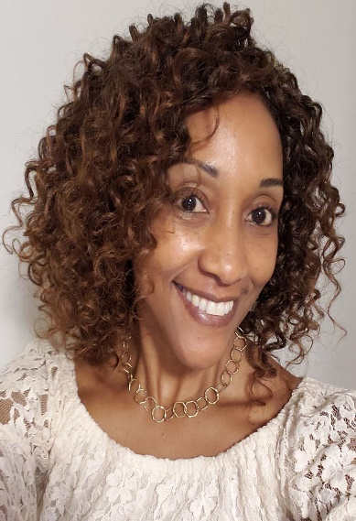

.

Dr. Keyona (Evans) Hall

Dr. Keyona (Evans) Hall is a Nationally Certified Counselor and currently holds licensure in the state of Maryland as a Licensed Clinical Professional Counselor. She earned her Doctorate degree in Counseling Education and Supervision and her master’s degree in Counseling Psychology.

Sonia Hinds APRN, PMH-BC, RPT-S

Founder and Director of Chesapeake Beach Professional Seminars LLC. Executive Director of Barstow Acres Children’s Center, a non-profit organization that provides children’s mental health services. Trained in Gestalt play therapy with Violet Oaklander (retired). Authored Chapter, Play Therapy with African American Children in text, Cultural Issues in Play Therapy by Eliana Gil, Ph.D., RPT-S and Athena Drew, Ph.D., RPT-S.

Dorcas Matowe

Dorcas Matowe has extensive work and volunteer experience in mental health and has worked with multicultural populations of all ages. She served as a Board Member for the Broward Association for Marriage and Family Therapy in FL, through which she advocated for policy changes to improve mental health services.

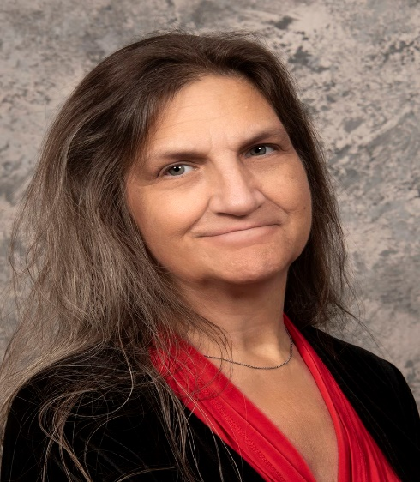

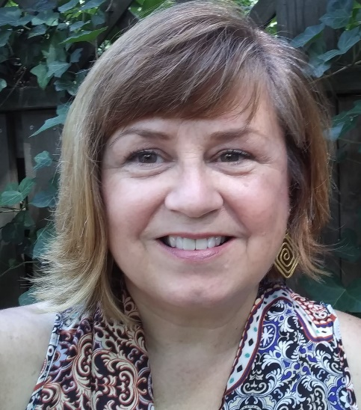

Carol ZA McGinnis PhD, LCPC, BC-TMH, SIP, NCC

Carol ZA McGinnis PhD, LCPC, BC-TMH, SIP, NCC is currently Associate Professor and Clinical Mental Health Track Coordinator in the Graduate Counseling Program at Messiah University. She currently serves as President of the Maryland Counseling Association (MCA), is trained as a Spiritually Integrated Psychotherapist (SIP) trainer through ACPE, and previously led the Maryland Association of Spiritual, Ethical, and Religious Values in Counseling (MASERVIC) division as president.

Vivian Morgan, MS, LCPC, CFTP
Vivian Morgan, MS, LCPC, CFTP has over 25 years’ experience working with children, young adults, and families and is an approved clinical supervisor in Maryland. She has a private practice in Lutherville, MD at True Balance Counseling Collective and is certified as a Family Trauma Professional, Mindful Meditation Practitioner, and in Mindfulness Based Stress Reduction for Teens.

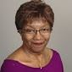
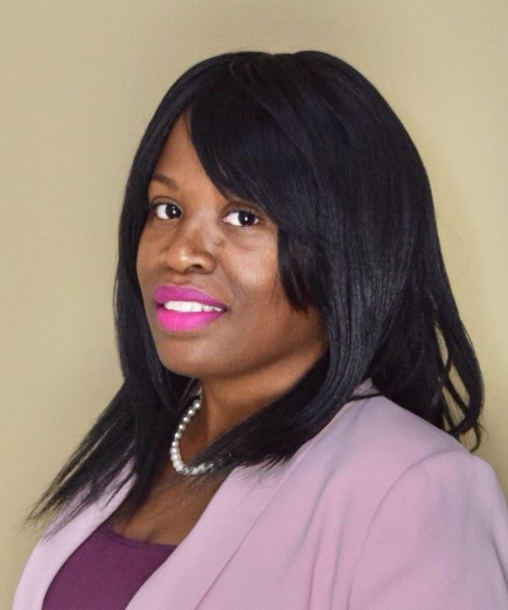

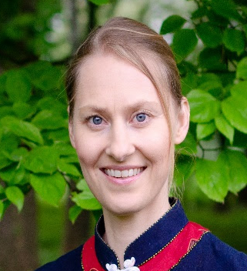
Elizabeth Nyang M.A. LCPC
Elizabeth Nyang M.A. LCPC is a licensed counselor and certified Tai Chi instructor who works with clients dealing with mood disorders and life issues. She integrates mindfulness and Tai Chi techniques in her practice to help clients reduce stress and gain insight into their problems.

Dr. Kizzy Pittrell, Ed.D.
Dr. Kizzy Pittrell Ed D. is a graduate of Argosy University, Washington DC from the Counseling Psychology program. Dr. Pittrell received her Masters of Counseling from Towson University and Bachelors of Science in Psychology from Bowie State University.
Dr. Pittrell is a Licensed Professional Counselor, an Approved Drug and Alcohol counselor, a Master Addiction Counselor, and an Approved Clinical Supervisor in Maryland. Dr. Pittrell has worked in the community sector providing mental health and addiction counseling and treatment to adults and adolescents for 15 years.

Dr. Heidi Schreiber-Pan PhD, LCPC
Dr. Heidi Schreiber-Pan PhD, LCPC, Clinical Director of Chesapeake Mental Health, Towson, MD is a successful psychotherapist, author, clinical director, and sought-after nationwide speaker on topics of resilience, anxiety, neuroscience, and occupational burnout.

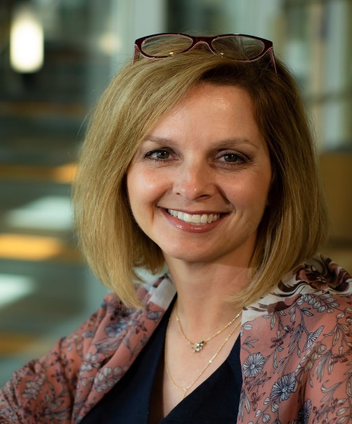
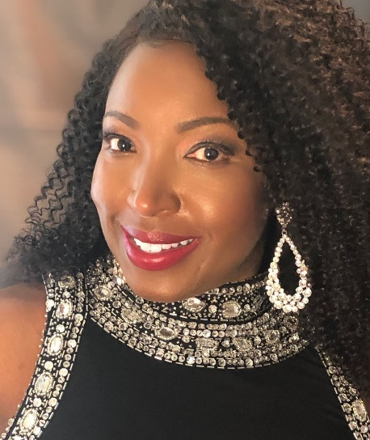

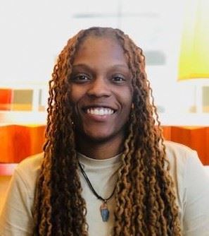

Robyn Trippany Simmons EdD
Robyn Trippany Simmons received her Ed.D. in Counselor Education from the University of Alabama in 2001 and has been a practicing counselor since 1996. She serves as Professor in the Department of Counselor Education and Family Studies at Liberty University. Dr. Simmons’s research and clinical interests include sexual trauma, vicarious trauma, play therapy, and professional identity issues. She is a Licensed Professional Counselor-Supervisor in Alabama and is a Registered Play Therapist Supervisor.

Dr. Deidra A. Sorrell
Dr. Deidra A. Sorrell is a licensed professional counselor, licensed clinical supervisor, and a certified school psychologist. She is the founder of Synergy Wellness Therapeutic Services where she provides individual counseling to children, adolescents and adults in the Waldorf and surrounding Charles and Prince George’s County areas in Maryland

Morgan Vice
Morgan Vice obtained her Master's degree in Applied psychology and counseling at the University of Baltimore in 2017. She is currently a Licensed graduate professional counselor (LGPC) at Thrive Behavioral Health.

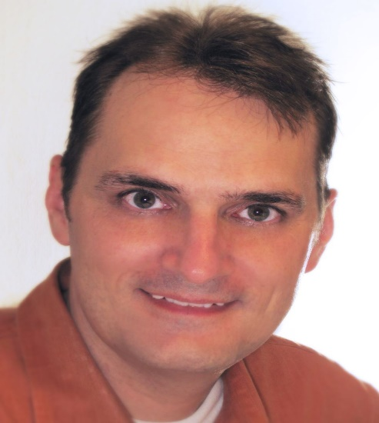
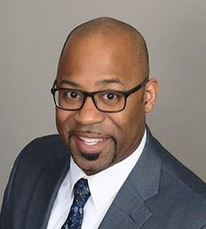

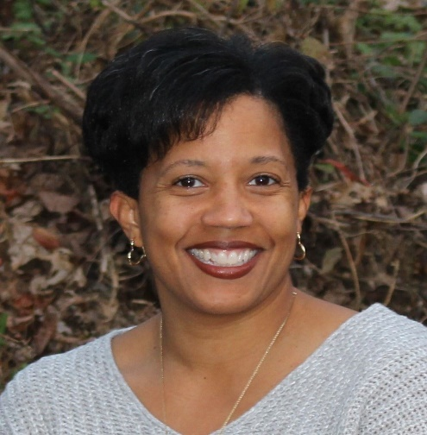

Jerry Vuncannon, Jr., PhD
Jerry Vuncannon, Jr. PhD is Assistant Professor of Graduate Counseling with Liberty University and has worked in counselor education since 2006 with the last 7 years in full-time capacity. His teaching and/or research interests include attachment relationships, multicultural work, and counseling issues as it relates to international settings.

Dr. Jarvis M. Watson
Dr. Jarvis M. Watson is a motivator, connector, and change agent for equity and inclusion. He currently serves as the Assistant Dean for Student Support and Inclusive Education at Stony Brook University. He also serves as an adjunct professor with the School of Professional Development (Educational Leadership Program) and the Department for Africana Studies: and he assists with curriculum development for the Higher Education Administration Program.

Roni K. White, NCC, LGPC
Roni K. White, NCC, LGPC, is the founder and therapist of Apricity Wellness Counseling. She created the “Women in the Workplace: Leadership, Barriers, & Struggles” series. Ms. White’s professional work encompasses counseling in the areas of mental health, career, college, wellness, and pastoral counseling.

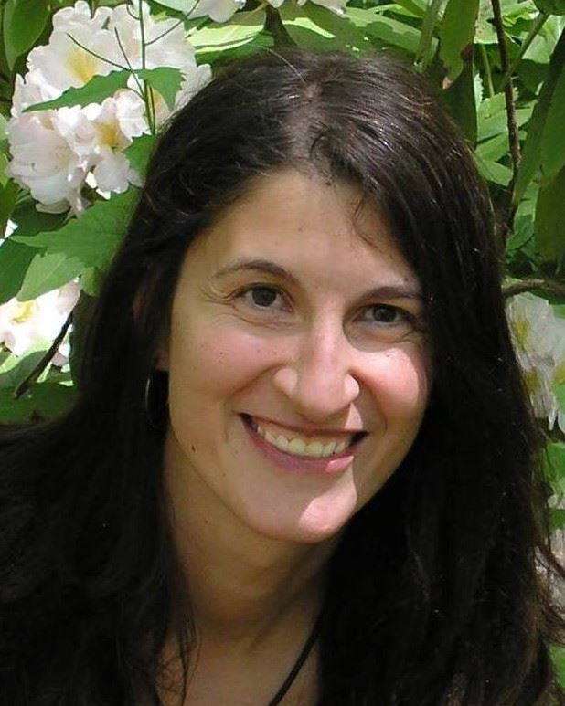

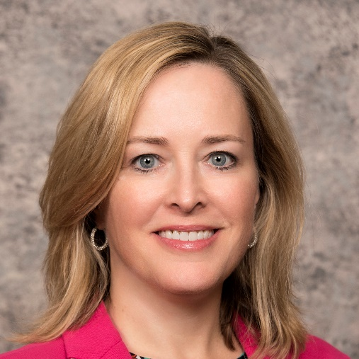

Dr. Daria White
Dr. Daria White is a native of Bulgaria, with a Ph.D. in Counseling and Supervision. She has 20 years of experience in the fields of mental health counseling, social work, and peacebuilding. She has integrated conflict transformation and counseling practices, focusing on multicultural dynamics and ethics in her work with refugees from the Middle East, survivors of domestic violence, and communities that have experienced trauma, marginalization, and political oppression. Dr. White is an Assistant Professor at Liberty University, continuing work and involvement with trauma and restorative justice work in her home country Bulgaria.

Dr. Sara Pula
Dr. Pula is the President-Elect of the Maryland Counseling Association, Past President of the Maryland Association for Counselor Education and Supervision, and Treasurer and Past Chair of the Board of Advisors of the Anne Arundel County Department of Social Services. Dr. Pula serves as CORE Faculty in the counseling program at Capella University. As leader in the field, she facilitates workshops, supervises counselors toward licensure, and provides advocacy at the local level. Her most recent advocacy efforts helped lead to the passing of SB 810, a bill authorizing the Maryland State Highway Administration to display suicide prevention information on electronic highway signs. Dr. Pula is also the owner of Pula Counseling and Consulting, LLC, and specializes in working with adolescents, treating body image dissatisfaction, eating disorders recovery, and trauma-related issues. Dr. Pula is the author of a 3-CEU course “Body Image and Dissatisfaction: Theories and Cultural Considerations,” which can be found on the Western Schools web site.

MCA CONFERENCE SUPER SPONSOR

Join us in our expression of appreciation and thanks to Messiah University for their generous conference sponsorship. Please consider their online CACREP-accredited Graduate Counseling Program when referring young clinicians to pursue licensure.

Messiah University offers three degree tracks in School Counseling, Clinical Mental Health Counseling, Marriage, Couple, and Family Counseling, and a robust Certificate of Graduate Study. Unique courses provide guidance for ethical practice based on the American Counseling Association (ACA) Code of Ethics, and counselors can “brush up” on many topics to maintain licensure and competency.
Other graduate programs may pique your interest or be helpful to share when conducting career counseling with your clients. Be sure to take a moment to check out the Messiah University website to see what may be useful in your practice as a professional counselor:

WWW.MESSIAH.EDU

